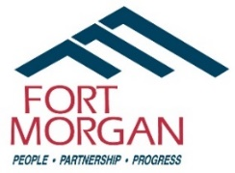
Senior Center Advisory Board Meeting
Monday, January 12th, 2026, at 1:30pm

Agenda
- Call to Order

- Roll Call
- Deb Elrick
- Virginia Foley
- Chuck Morgan
- Jim Sinnott
- Matt Underwood
- Monty Waite
- Rachel Hood
- Jon Kaper

- Approval of November 2025 Meeting Minutes

- Unscheduled Citizens
- Reports
  - Board Updates
  - City Councilmember John Kaper
  - Director of Community Services Matt Underwood
  - Recreation Superintendent Monty Waite
  - Senior Center Coordinator Rachel Hood

- 2026 Programming Overview

- Selection of New Board Members

- Next Meeting Date – Monday, March 9th, 2026 @ 1:30pm.

- Adjourn

