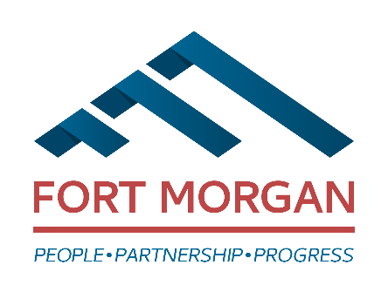
City of Fort Morgan
Historic Preservation Board Meeting
Thursday, January 8, 2026
4:00 p.m. at Historic City Hall/110 Main Street
(Second level floor)

AGENDA
- Call Meeting to Order
- Approval of Minutes – October 9 , 2025 (enclosure)
- Update on Neighborhood Driving Brochure
- CLG Requirements and Opportunity Updates
- Saving Places Conference February 11 – 13, 2026
- Main Street Application
- Calendar of Annual Dates (enclosure)
- Public Comment/Audience Participation
- Announcements
- Adjournment

Staff Contact: Council Liaison:
Sandy Engle, Economic Development Specialist Loren Boyett, Councilmember
110 Main Street • P O Box 100 (Mailing Address)
Fort Morgan, CO 80701
Phone: (970) 542-3924
Email: sandy.engle@cityoffortmorgan.com

THIS MEETING IS OPEN TO THE PUBLIC
____________________________________________________________________________________________Individuals with disabilities needing auxiliary aid(s) may request assistance by contacting Jill Curtis, City Clerk, 110 Main Street, Fort Morgan, Colorado, at (970) 542-3962 or by fax at (970) 542-3968. We would appreciate it if you would contact us at least 48 hours in advance of the scheduled event so arrangements can be made.

