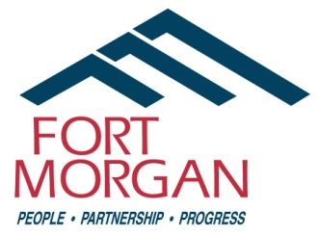
City of Fort Morgan
Historic Preservation Board
Work Session
Wednesday, February 5, 2025
4:00 p.m. at City Hall – 110 Main Street
(Second Floor City Council Chambers)

Agenda

- Update on CSU-led preservation project involving Spanish Colony in Morgan County
  - Introduction of CSU graduate student team members
  - Review scope, purpose, and timeline of project

Staff Contact:
Sandy Engle, Economic Development Specialist
110 Main St. • PO Box 100 (Mailing Address)
Fort Morgan, CO 80701
Phone: (970) 542-3924
Email: sandy.engle@cityoffortmorgan.com

THIS MEETING IS OPEN TO THE PUBLIC

Individuals with disabilities needing auxiliary aid(s) may request assistance by contacting John Brennan, City Clerk, 110 Main Street, Fort Morgan, Colorado, at (970) 542-3963 or by fax at (970) 542-3968. We would appreciate it if you would contact us at least 48 hours in advance of the scheduled event so arrangements can be made.

