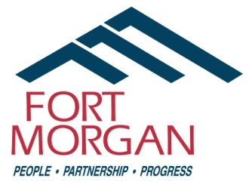
City of Fort Morgan
Historic Preservation Board Meeting
Thursday, April 10, 2025
4:00 p.m. at City Hall – 110 Main Street
(Second Floor)

Agenda

- Call Meeting to Order
- Approval of Minutes – January 9, 2025 (Enclosure)
- Training on Secretary of the Interior’s Design Standards - Lindsey Flewelling, Ph.D. (Preservation Planner/Certified Local Government (CLG) Coordinator, History Colorado)
- Neighborhood Driving Brochure Update
- CLG Requirements and Opportunity Updates
  - Potential Projects to Celebrate Archeology & Historic Preservation Month in May
  - 2026 Colorado 150th Birthday Celebration/United States 250th Anniversary of the Declaration of Independence and Potential Local Landmark Nominations
  - CSU Spanish Colony Preservation Project Update
  - Comments/Discussion on the Saving Places Conference held January 29 to February 1
  - Other
- Public Comment / Audience Participation
- Announcements
- Adjournment

Staff Contact: Council Liaison:
Sandy Engle, Economic Development Specialist Loren Boyett (Councilmember)
110 Main St. • PO Box 100 (Mailing Address) 970-590-5921
Fort Morgan, CO 80701
Phone: (970) 542-3924
Email: sandy.engle@cityoffortmorgan.com

THIS MEETING IS OPEN TO THE PUBLIC

Individuals with disabilities needing auxiliary aid(s) may request assistance by contacting John Brennan, City Clerk, 110 Main Street, Fort Morgan, Colorado, at (970) 542-3963 or by fax at (970) 542-3968. We would appreciate it if you would contact us at least 48 hours in advance of the scheduled event so arrangements can be made.

