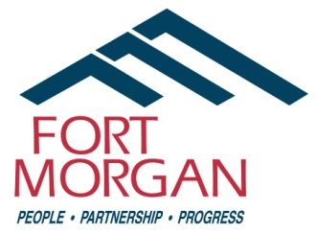
City of Fort Morgan
Historic Preservation Board Meeting
Thursday, July 10, 2025
4:00 p.m. at City Hall – 110 Main Street
(Second Floor)

Agenda

- Call Meeting to Order
- Approval of Minutes – April 10, 2025
- Update on Neighborhood Driving Brochure
- CLG Requirements and Opportunity Updates
- CSU Spanish Colony Preservation Project Update
- Proclamation for Archeology & Historic Preservation Month (enclosure)
- History Colorado Regional Forum presentation (enclosure)
- History Colorado State Preservation Plan-Goals & objectives will need to be referenced in grant applications & CLG programs www.historycolorado.org/state-preservation-plan (enclosure)
- Discussion of potential projects for the 150/250 celebration next year and potential local landmark nominations
- Public Comment/Audience Participation
- Announcements
- Adjournment

Staff Contact: Council Liaison:
Sandy Engle, Economic Development Specialist Loren Boyett (Councilmember)
110 Main St. • PO Box 100 (Mailing Address) 970-590-5921
Fort Morgan, CO 80701
Phone: (970) 542-3924
Email: sandy.engle@cityoffortmorgan.com

THIS MEETING IS OPEN TO THE PUBLIC

Individuals with disabilities needing auxiliary aid(s) may request assistance by contacting Jill Curtis, City Clerk, 110 Main Street, Fort Morgan, Colorado, at (970) 542-3962 or by fax at (970) 542-3968. We would appreciate it if you would contact us at least 48 hours in advance of the scheduled event so arrangements can be made.

