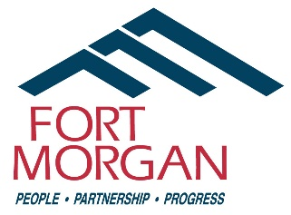
REQUEST FOR INFORMATION

PURSUANT TO THE COLORADO OPEN RECORDS ACT

INSTRUCTIONS – Print this page before completing and signing; then submit the form by:
FAX to 970-542-3968; Attention City Clerk Jill Curtis; or
MAIL to City Clerk, P.O. Box 100, Fort Morgan, CO 80701; or
IN PERSON at City Hall, 110 Main Street, Fort Morgan, Colorado; or by
EMAIL to: jill.curtis@cityoffortmorgan.com, lori.lorenzini@cityoffortmorgan.com

Questions? Call City Clerk Jill Curtis at 970-542-3962.

PLEASE PRINT

Name: _________________________________ Date of Request: _________________

Address: __________________________________________________________________

City: ____________________________ State: ______________ Zip Code: __________

Phone Numbers – Day: _________________ Evening: ____________________

E-mail Address: ___________________________________________________

SIGNATURE: _____________________________________________________

======================================================================

Indicate the information you desire and/or list each requested document. Please be as specific as possible. Allow three (3) working days for a search of the records.
____________________________________________________________________________________________________________________________________________________________________________________________________________________________________________________________________________________________________________________________________________________________________________________________________________________________________________________________________________________________________________________________________________________________________________________________________________

